2.5d:
Research article
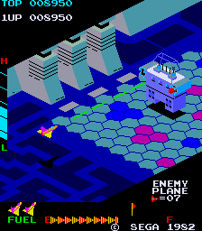
Introduction:
2.5d has had 2 different definitions since its emergence with it originally referring to the ability to render a 3d environment using 2d graphics using techniques like sprite scaling, parallax scrolling, billboarding and axonometric/ oblique projection. These techniques allowed players to have the illusion of a constrained 3d view of the game whilst staying within the limitations of the engines and console capabilities at the times creating a pseudo 3d environment.
The term was originally coined by Warren Spector within pc gamer issue 01 (May of1994) where he was interviewed about his upcoming game system shock where in it, he compared titles like “Wolfenstein 3d or doom as “two and half d”” (warren Spector (01)). (Whilst the term may have been used earlier this was the first publicized use of the term), as time went on and technology advanced the genre of 2.5d switched slowly throughout the 1990-2000s to more closely define what we now see as 2.5d with idea of a pseudo 3d environment no longer being its defining feature, instead the inverse with the defining features being a 3d environment graphically with a 2d focused gameplay style with little to no movement within the other axis that 3d allows for.
The first:
There are arguably 2 title that could be classed as the first game to use the genre with Taito’s interceptor (1975 locally, 1976 abroad (02)) being the first game to use the 2.5d genre within its original definition, but on the other hand you have Sega/gremlins zaxxon (1981 Japan 1982 globally 1983 console (03)) which more closely follow the genre conventions of the modern definition.

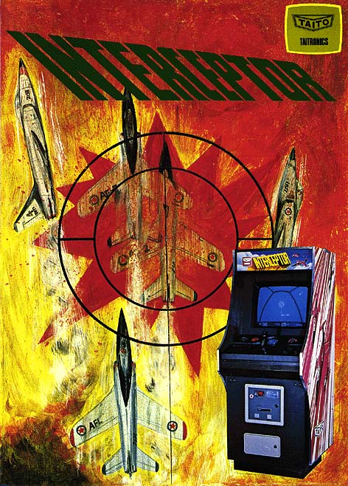
Interceptor:
Released in 1975 in Japan, then a year later abroad Taito’s interceptor was an arcade cabinet exclusive in a standard upright cabinet featuring an 8-way joystick and a singular button. alongside this you had a raster standard resolution monitor with a black and white screen with a colour overlay.
Commercial the cabinets was a success enough to launch globally and is considered a pioneer within its technology used within it programming, with it being one of the first games to use sprite scaling and multi directional scrolling within it gameplay.
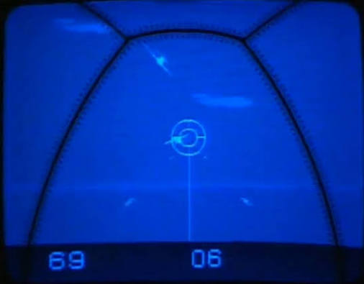
Gameplay wise it you play in a fighter pilots pov with the ability move around the sky in any direction within a pseudo 3d environment, during your play time you search for enemy fighter jet to shoot down with your machine gun. the player is put on a 90 second timer and can extend this by achieving certain score threshold. The game also features “authentic sounds of jet aircrafts in steeps dives and high-speed chases” (interceptor flyer (04))
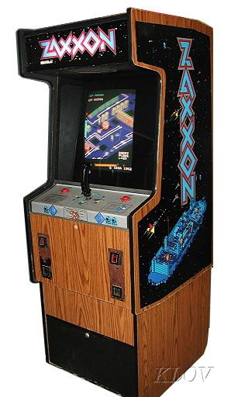
Development-wise it was produced by Taito’s and was made by Tomohiro Nishikado of space invader fame. Before it released nishikado had released 6 other games these being super road 7, sky fighter 2, soccer (deluxe model), soccer, Davis cup, speed race and western gun. (05)
Interceptor is arguably the first 2.5d game, at least within in its original definition it is, but within a modern sense it follows more of the look of feel of a 3d game rather than what would be expected within a modern 2.5d game.
Zaxxon:
Released in 1981 in Japan and north America and Europe within 1982 then later ported to the Atari 2600 and Coleco-vision zaxxon alongside a pc port, is arguably the first 2.5d game within the modern sense as whilst it still does use 2d graphics for whole game it follows the genre conventions much more close with limited movement and forced perspectives.
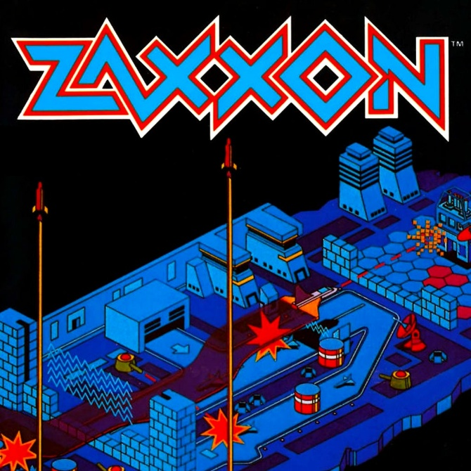
Within the arcade market zaxxon was released on a standard upright cabinet, cocktail cabinet and a cabaret cabinet, all these featured a raster standard resolution colour monitor, it had a maximum of 2 players with both players alternating control of the machine, featured a joystick that resembles a plane flight stick and 2 button each side of the machine that would allow for multiple players.
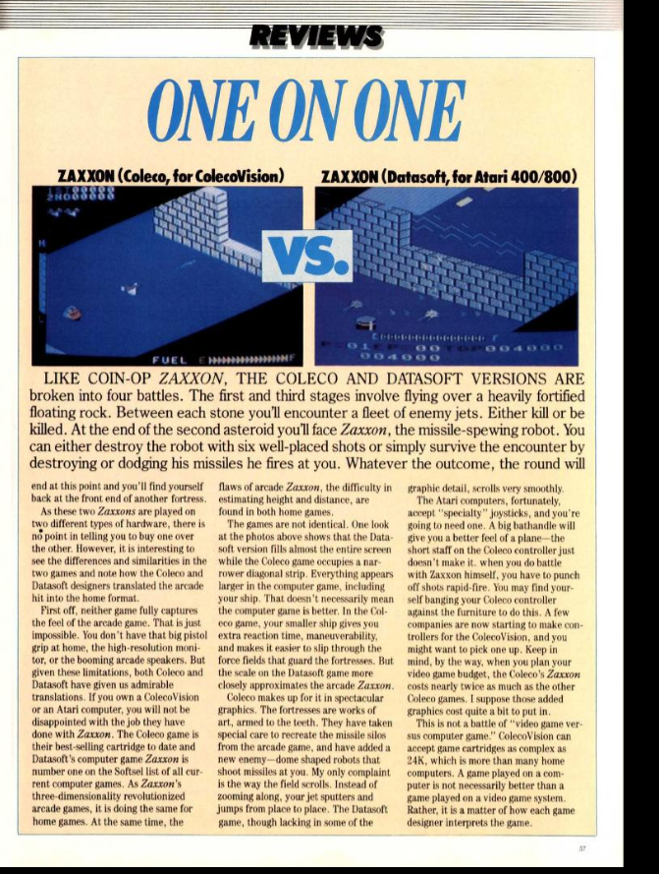
Commercially the game was a critical success porting to nearly every console and home pc at the time and continually winning top arcade machine in the upcoming years with it getting 18th highest grossing arcade game in 1981, in Japan according to game machine (06) and then got the 8th highest grossing arcade game in 1983, in Japan according to game machine, past Japan it saw more success and arguably a higher amount in north America with it reaching the top of the monthly us replay arcade charts in 1982, and was called the 8th highest grossing arcade machine in north America in 1982 by the amusement and music operators association (amoa). Past the arcades its success didn’t stop there as it many ports managed to garner success Aswell with video game players calling it “an admirable translation” (07) and proclaiming “The Coleco game is their bestselling cartridge to date and Datasoft's computer game Zaxxon is number one on the Softsel list of all current computer games.” (07). The pc ports also had major success within the market with zaxxon listed as the fourth best selling game on apple 2 in 1985(08) and eventually receiving a gold award from the software publishers association (spa) in December of 1978 for software sales above 100,000 units (09).
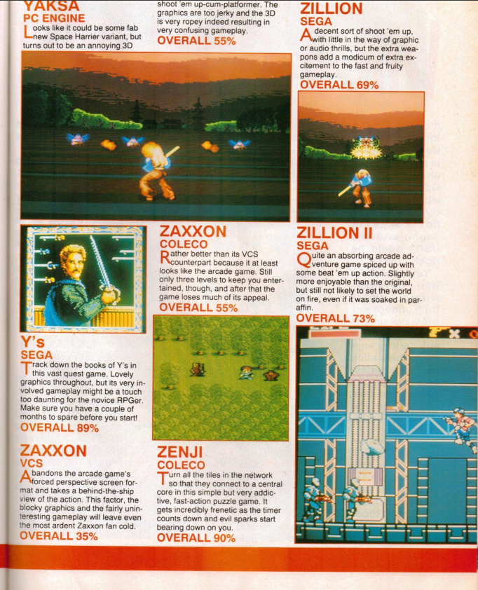
Review wise zaxxon ranges from very high to middling to terrible reviews the Atari 2600 port being especially disliked receiving a review rating of 33% with it stating “the blocky graphics and the fairly uninteresting gameplay will leave even the most ardent zaxxon fan cold”(computer and video games (10)), whereas the Coleco port scored much higher with a 55% with the reviewer complaining about it lacks of levels,(computer and videogames (10)), other review bodies rated the Coleco port much higher with arcade express giving it a 9/10 and video game player and electronic fun with computer and games both giving it a grade of A. On the home pc front the review were all on the higher end with k-power giving it an 8/10 and stating, “If you've played Zaxxon at the arcade, you won't miss any of the outstanding three-dimensional action by playing Datasoft's computer version.” (k power (11)), computer and videogames gave it a 39/40 (10) and video game player gave it a positive rating.
Gameplay wise:
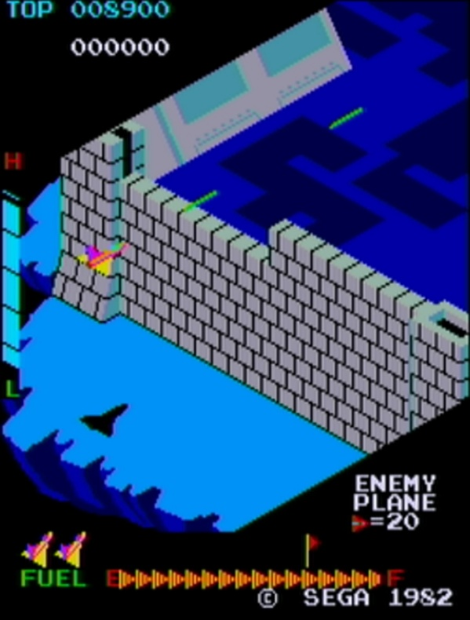
Arcade: developer/publisher: Sega/gremlin
Within the arcade version of zaxxon you play a spaceship flying a isometric 2.5d world using 2d graphic to give the illusion of a 3d environment the player can move to the left or the right Aswell as upward and downwards with a shadow cast by the ship to help tell the player their current height along with this a height gauge is featured in the left side of the screen to help the player in the pseudo 3d environment, during the game the player target is to shoot down as many targets as possible to increase their score and avoid enemy projectiles and walls, the target can range from missile silos to enemy ships and many others. The player goal is to reach the end of the level where they then face a “zaxxon” which is visually a giant robot which if not defeated quick enough launches a homing missile to end your current life or game, if beaten you are then thrust into the same level with at time slightly reskinned enemy e.g. enemy planes turn from grey to yellow, will start to appear, along with this the level become faster and faster until the player is defeated. If a player is skilled enough to not die the fuel mechanic comes into place which will end your current life if it fully empties. (12)
Differences:
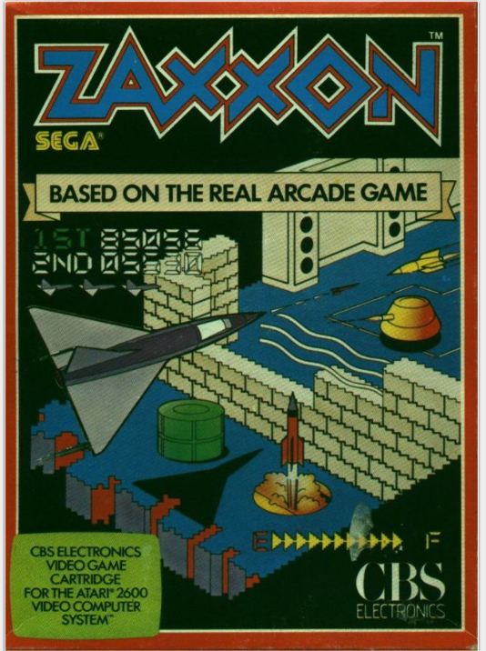
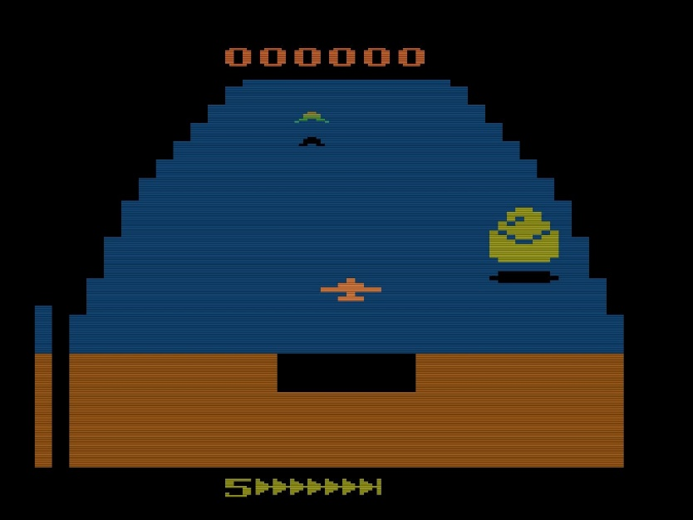
The Atari 2600 (CBS electronic) port graphically downgrades the game significantly, changes the isometric view for a behind the ship pov and simplifies the gameplay significantly, many people perceive this port as a bad translation from the original arcade game, along with this audio wise the game is a significant downgrade along with omitting the multiplayer mode. (13)

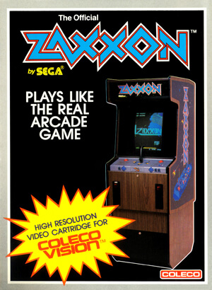
Coleco-vison (4d interactive system) graphically is a somewhat downgrade but no where near as bad as the Atari 2600 port, it feature less sfx and completely omits the background music featured in the arcade, it keeps the isometric view but does implement it in a much choppier fashion, primarily due to system constraints along with this the boss is much less detailed graphically and has less animations. The port also features a unique feature in a difficulty system with four different level of difficulty available. Out of all the ports this is by far considered the best and most accurate port. (14)
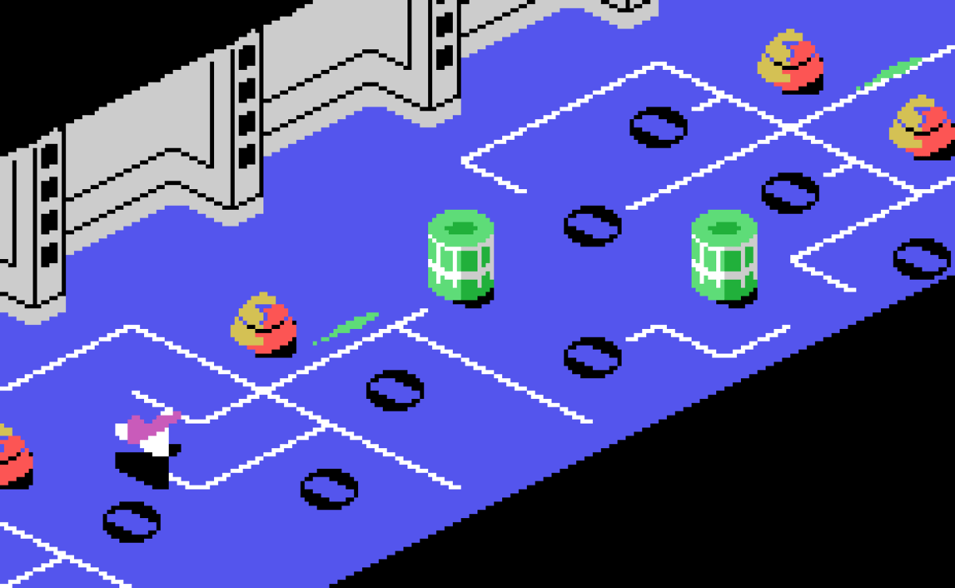
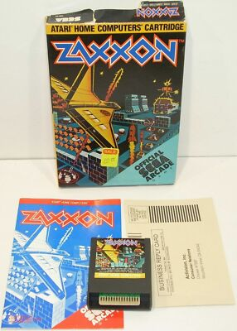
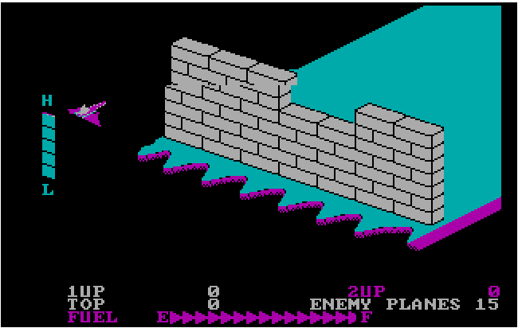
Home pc (synapse software/ datasoft) port once again has a graphical down grade with less details and less sprites, whilst not as bad as the Atari 2600 port it still doesn’t beat the Coleco-vision, along with this the maps layouts were slightly altered and the final boss was simplified and made more static, sound wise background music is omitted once again and the sounds are on a lower quality than the Coleco-vision. (15)

Due to the viewpoint and limited movement the game follows many of the genre conventions that are seen inside of the 2.5d genre, and is therefore classed as a 2.5d game with it using many of the techniques mentions earlier to create this illusion including isometric axonometric projection, dynamic sprite shadows and sprite scaling, these techniques allow the game to function as if it was in a 3d space but the gameplay itself is still very limited to a 2d plane with movement inside the pseudo 3d space locked in place with no choice but to be on rails and your only movement options being to go left or right on the screen or up and down.
Evolution of the genre:
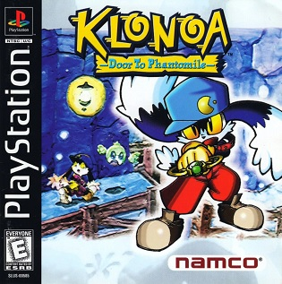
The 2.5d genre has heavy roots within the 2d space with many title in this genre originating from the effort made from developers to create a pseudo 3d space, but as time went on and technology advanced 3d became more accessible and easy to use within game production, due to advancement within engines and console/pc capabilities, during this time the genre slowly evolved due to many development team who were experienced within 2d adjusting to the 3d space as whilst many teams focused on using 3d to it full advantage e.g., Mario 64, glover, croc legend of the gobbos, many teams tried to adjust the 2d formula to a 3d space with the gameplay still functionally resembling a 2d game but within a 3d environment e.g. odd world, klonoa: door to the phantomile, kirby 64 and the crystal shards. During this period the genre started changing meaning with 3d games getting more complex and different from their 2d origins, it made 3d games that still stuck their 2d roots stick out and become more of their own genre due to their unique gameplay stylings and features.

Many people see popularization of this style of 2.5d from the release of klonoa: door to the phantomile (released in 1997 in Japan and 1998 in the west) originally a title exclusive to the ps1. As it was one of the first take the 2d gameplay aspect of platformer and combine it with a 3d environment.
Many other big titles have been released in this genre in the more modern year with new super Mario bros games series being arguably one of the biggest 2.5d series that’s still releasing, originally starting out on the ds as a handheld version of Mario experience it was later given sequels and remasters on many of their console with the Wii-u having new super Luigi bro’s and super Mario bros deluxe on the Nintendo switch, this series would adapts the roots of the Mario series into a 2.5d version, evolving the concept with new power-ups, new characters and more world themes.
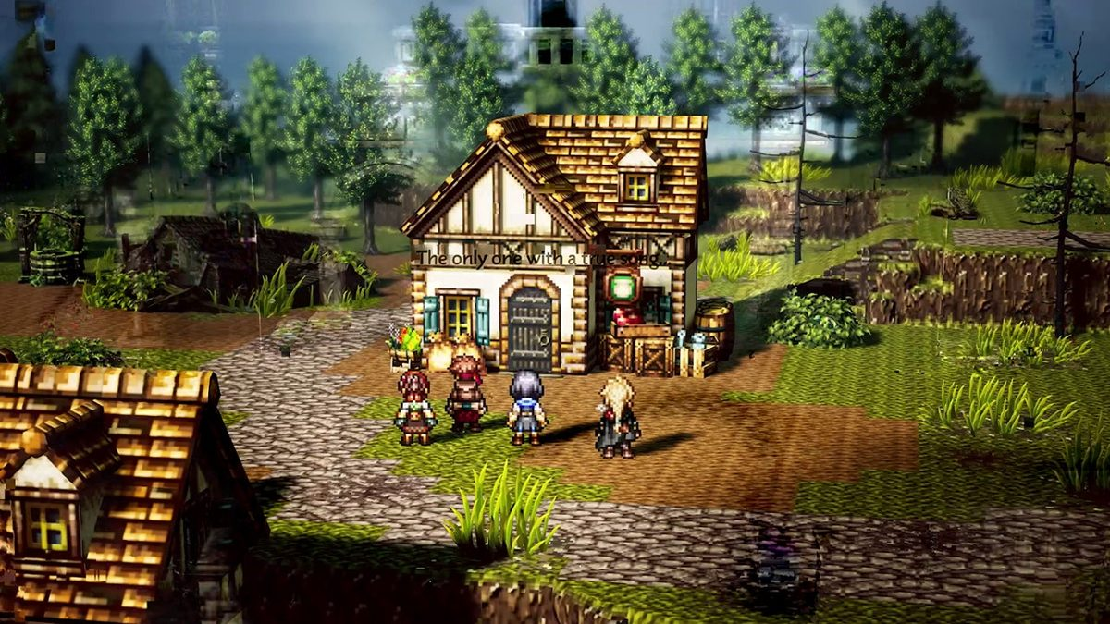
Within the more recent years other titles have been using the art style and approach to revolutionize traditionally 2d games adding levels of depth to pixel based Rpg, to include cinematic lighting and real time shadows within their games, one of the best examples of this is the octopath traveller series with it being one of the first modern pixel Rpg to start using this style to enhance their world feel and visuals. This style has also inspired changes within traditional 2d based engines with the new Rpg maker engine Rpg maker u2u including a 2d-hd/2.5d style support.
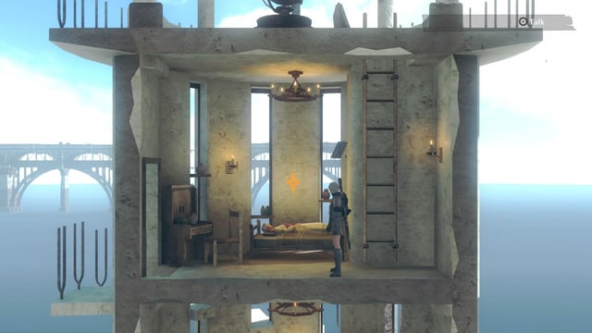
Conclusion:
Overall, the 2.5d genre is a very broad and up to interpretation genre, whilst it does feature some stable elements such as a fixed perspective and limited controls, it changes per person on how they visualize and see the genre as some may say that the genre can only include minor 2d elements whilst some may say a game could be completely 2d and still be classed as 2.5d, others may say it can’t have any movement that would be in 3d space, whilst other would argue that limited movement still keep it viable as 2.5d.
My main point is Genres are always in constant flux and 2.5d is no different it already changed meaning over the 1990-2000s with the advent of 3d becoming main place within the gaming environments and now you have the somewhat still emerging art style of 2d-hd which use many techniques found within the 2.5d genre.
The genre itself heavily decisive and always changing it allows for heavy creative freedom but is easily strayed away from due to it broad and vague nature.

Gameplay analysis:
Klonoa and the phantomile door:
Genre: 2.5d platformer
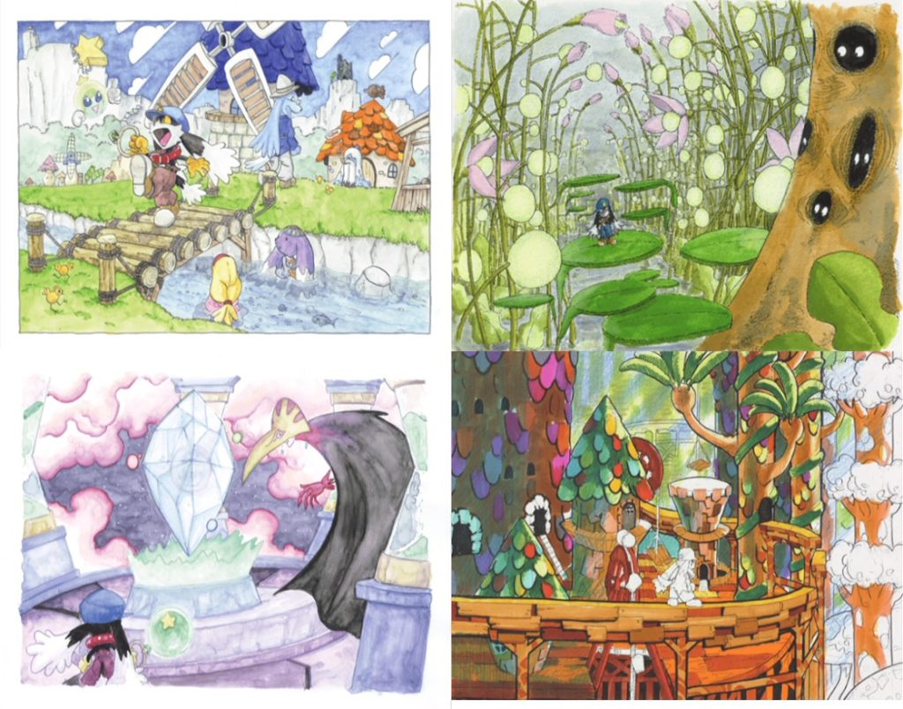
Playthrough: https://www.youtube.com/watch?v=S9P_OITM2ek (16)
Klonoa was released on December 11th, 1997, in Japan then 3 months later it would receive a north American and European release. It was originally a ps1 exclusive, until around 8-9 years later the original game would be added to the Japanese exclusive Namcollection for the ps2, eventually it was remade for the Wii in 4th of December 2008 for Japan then having a global release 5 months later, round this time a scaled down version of the game would be released for mobile device round 2008 but only exclusively within Japan. Finally, you have the final remaster released in 2022 globally.
It was developed and published by Namco to great critical success but lacked fiscal success outside of Japan.
Plot synopsis:
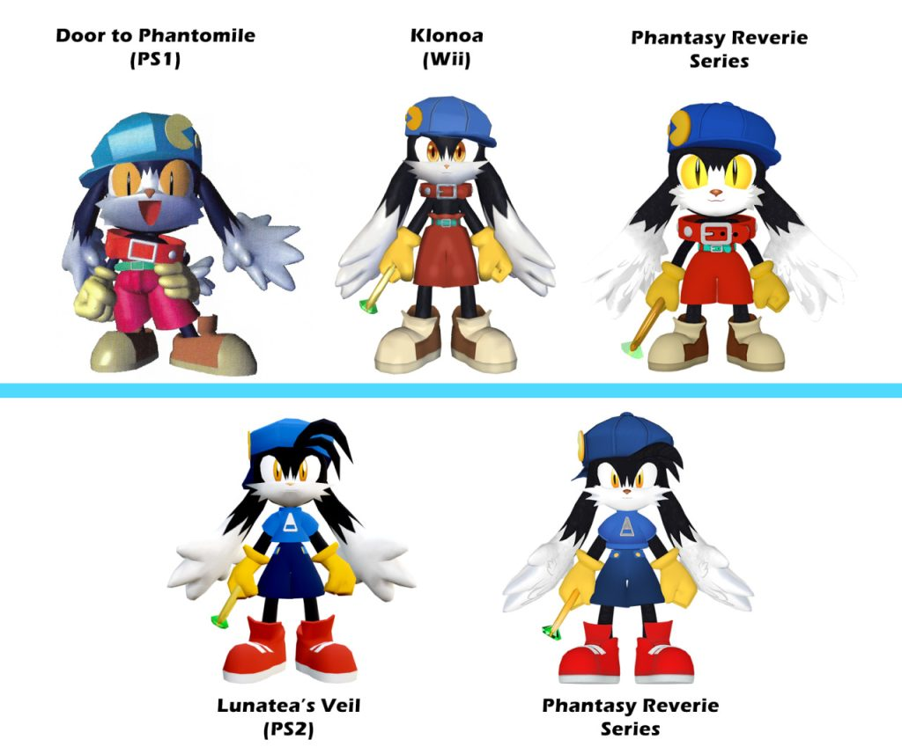
Setup:
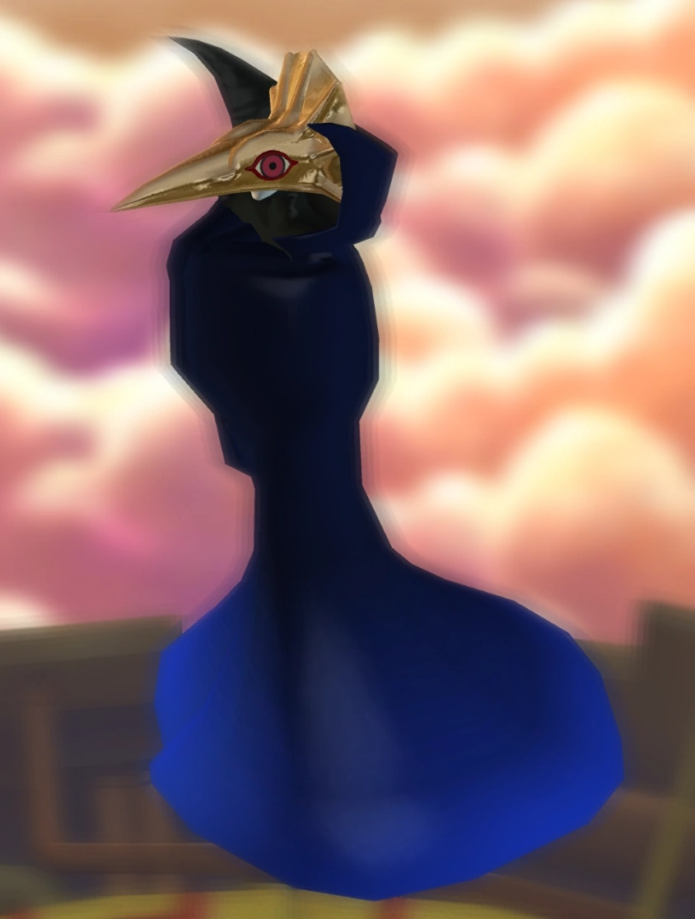
Within klonoa we follow our titular character klonoa and his friend huapow a floating blue orb character, within the world of phantomile, a world fuelled by dreams. were introduced within the intro cutscene of theming of dreams that is followed throughout the game, with a certain dream that klonoa has been having sticking out specifically, as if they had “saw it with my own eyes” (16). Within this dream we see klonoa and huapow playing around until something crashes on top of bell hill turning the world into a permeant nightmare, once klonoa wakes up from this dream we see the “legendary diva” (16) lephise crashing into the top of bell hill, klonoa and huapow follow the crash to find joka and ghadius our 2 main villains kidnaping the legendary diva and proclaiming their plan to lock up the diva into a permeant darkness allowing ghadius to destroy the world and turn it into a world of nightmares, after a short boss fight against a creature summoned by joka, klonoa find the moon pendant and is set on their journey that will eventually lead them to save the world.
Throughout the game we travel throughout 6 different themed areas with a progressively harder difficulty, requiring further mastery of the move set/game mechanics, within the journey you go around trying to foil the plans of ghadius but find joka stopping you and blocking you with another summoned creature. Eventually all hope seems to be loss, with your grandpa dead and the moon pendant in the hand of the enemy, within this darkest moment an earlier boss who was under the control of joka, comes back to take klonoa to the sun temple to take down ghadius, when klonoa is face to face with ghadius and joka we learn of the motivation of ghadius, with his motives being revenge against the people who banished him into the darkness, you then face off against joka in a boss battle, once you beat joka you then go to the moon kingdom to stop ghadius from enacting his plans, it at the moon kingdom huapow reveals his true identity to be the prince of the moon kingdom, eventually you then face off against ghadius but even with his defeat his plans begin to succeed with him using lephise as a living battery alongside his own nightmares to summon nahatomb, klonoa beat the monster and restore peace to the phantomile.

The plot doesn’t end there as huapow then reveals that all klonoa memories prior to the adventure was all fabricated by himself so he could save the phantomile, and when the song of rebirth is sung klonoa will be transported back to his own world, shortly after the song is sung and a vortex is summoned in the sky and klonoa is slowly sucked in, within this moment huapow try to grab the wind ring to keep klonoa within the phantomile but eventually his grasp slips and klonoa is sent back to their own world.
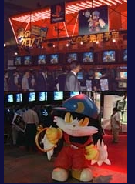
Commercially:
Early impressions:
Klonoa was announced at e3 1997 with a video demonstration with Namco stating that they hoped the cartoonish art style would better target their target audience of children (17), IGN would see this game as “fairly imaginative” (17) and compare it to Pandemonium a similar game functionally released in 1996 by crystal dynamics. Outside of the west it would also be featured at the 1997 Tokyo gameshow were a playable demo would be featured alongside an actor within a klonoa costume. (18) Japanese outlets would highlight the “stunning opening movie” (18) and see the title appealing to more female viewers, alongside this they would highlight the mascot and would highlight his inability to “move as nimbly as he did in the game” (18).
Reviews:
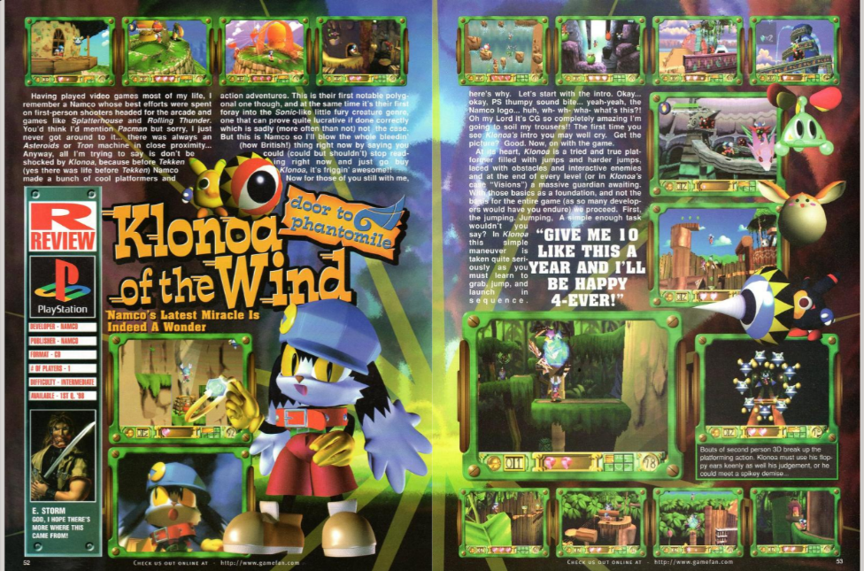
Official US PlayStation magazine: would score klonoa a 5/5 with them stating “this is a perfect platformer for younger gamers, and equally good for adults who can look past the cutesy exterior, its just plain fun”(19) the outlet also saw the complexity’s within the 2.5d engine with them comparing it pandemonium, saying that comparably to the title it use the 3d aspect much more with branching pathways the ability to interact within the other planes and levels not sticking to the 2d perspective, overall they say the game as having more “depth than similar platformers” (19), the only problems they could identify was the objectiveness of the graphic as some player may dislike the style alongside this they saw certain levels as overly complex and confusing.
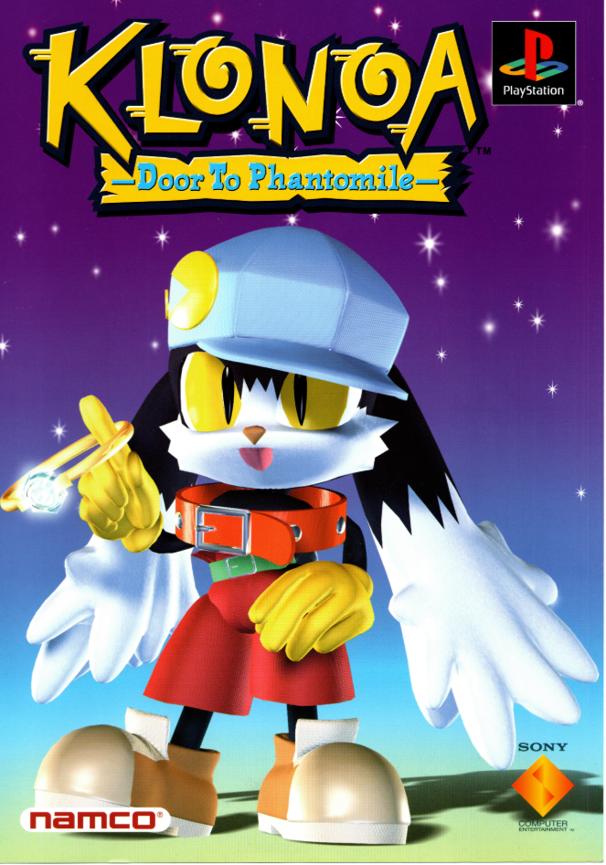
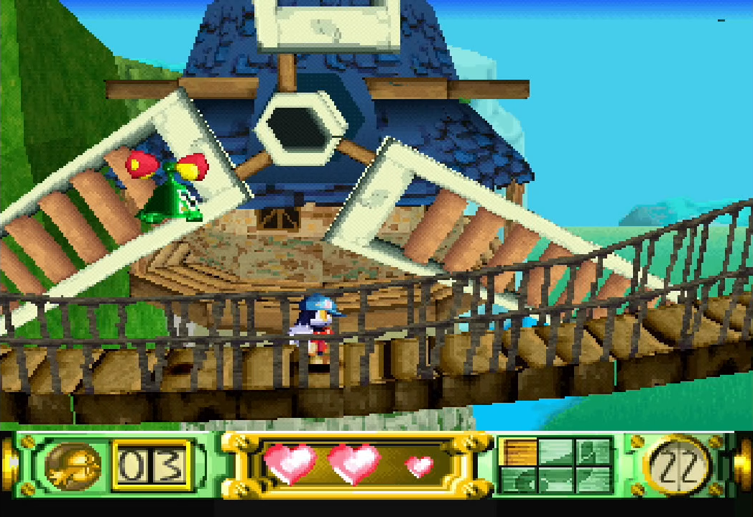
IGN: IGN would score the title an 8/10 seeing the genre of 2.5d as a badly executed genre at time, with klonoa being one of the first to perfect the genre with them stating it as “the first 2.5D platformer that makes use of classic 2D game elements without sacrificing the versatility of a 3D environment” (20), they claimed the game mechanics introduction and evolution of them as “almost effortlessly” (20) learned. The 3d environment was seen as cleverly implemented and used within the levels, with paths being clearly defined and almost feeling as if the game isn’t stuck on rails. The only problems the outlet could identify was the lack of levels and that bosses could be on the overly difficultly side, with them stating that klonoa was at least “In the platformer genre…. arguably the best one on the market” (20) and to not “let this one pass you by. “(20)
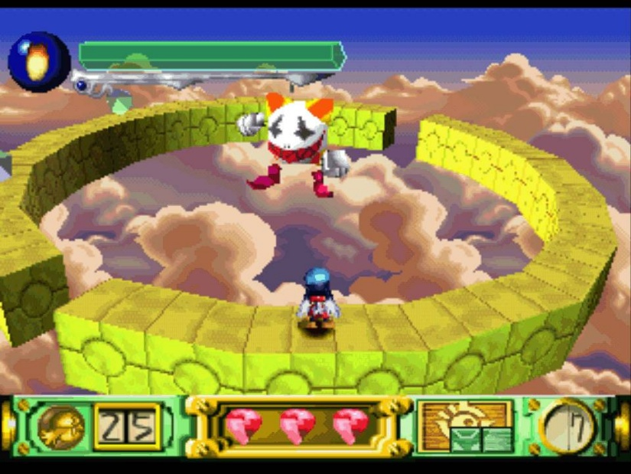
Hyper: A rating of 91 percent would be given by hyper saying “2.5d platforming doesn’t get better than this” (21) with the source calling the “mechanics…. solid and the use of the 3d illusion is used to good effect” (21) weirdly enough the source would state that “lame ripoffs” (21) would follow such as pandemonium, even though the title had released prior to klonoa the source would also call klonoa the “shiznit” (21).
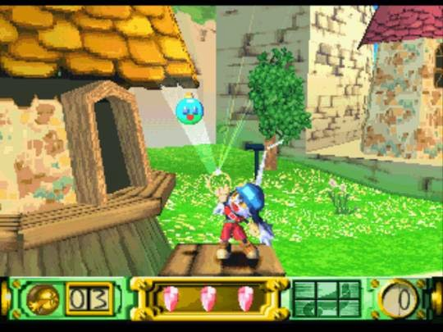
Gamespot: the title would receive another high rating with a 9.2 the outlet wouldn’t categorize the title a 2.5d instead calling it a side scroller that brings the “old school fun of super Mario bros. and the sonic games” (22) to the PlayStation but it would compare the title other 2.5 title with pandemonium coming up again, but within this comparison the source would say that klonoa succeeds “without resorting to gimmicks” (22). The source would also praise the use of the 2 main mechanics that klonoa can use to platform saying that “levels never get repetitive because you must continually think of new ways to use the few abilities you have.” (22). Whilst the source praises the use of the 3d environment calling it “a pseudo 3d environment” (22), it does also mention that a problem occur at one or 2 points within the game due to use of the 3d space, with its use not aligning well gameplay-wise due to perspective, but that’s not all it would praise as it would lament over how good the visual are with them seeing the levels/enemies as visually diverse and the cutscenes within game in and out of engine being “excellent” (22), whilst the source would also call the visuals technically great it would state that the psychedelic colour choices and surreal visual could be a problem for the player. Overall, the major issues the source would see within the game was it length and that it’s a “bit too cute” (22) but the suffix to this would be that players who could look past it would be able to enjoy a diverse and continually interesting level/boss design and a nice amount of difficulty ramping.
Gamefan: in a surprising rating system klonoa would score a 276/300, it gave a very enthusiastic review of game, especially entranced by the opening cg saying, “Oh my Lord it’s CG so completely amazing I’m going to soil my trousers!!” (23). Within the platformer genre the source would say it was a “complete an overall package as the genre has seen thus far.” (23) alongside this it would be especially impressed by it stable 60 fps, level/ boss design wise the source would say that it was “genius” (23) and “aesthetically wondrous” (23) whilst keeping a good level of challenge.
Other sources:
Game informer would give the title an 8/10.
Edge would give the title a 7/10. (25)
Computer and video games would give the title a 3/5
Awards:
Namco would receive best character in 1997 for klonoa in the Japan game awards (26), it would also receive best platformer of the year in 1998 by videogames.com (27) were the source would call the game a “huge sleeper hit” (27). Within December 14th klonoa scored fourth in weekly Japanese charts due to sales numbers of 51,441 this also made it the 2nd best selling PlayStation game at the time, it would remain in the top 50 for the next 10 weeks with sales reach 159,000. (30)
Sale wise klonoa would sell over 200,000 units (28) but this number is somewhat debated with other sources stating it sold 180,000 units with 0.17m in Japan and 0.1m in in the west (29).
Overall Klonoa is highly considered to be a finical success within Japan but a commercial failure in the west, but globally it received worldwide praise for its inventive game design and solidification of the 2.5d genre and even with lacklustre sale within the west the sequel still got a western release.
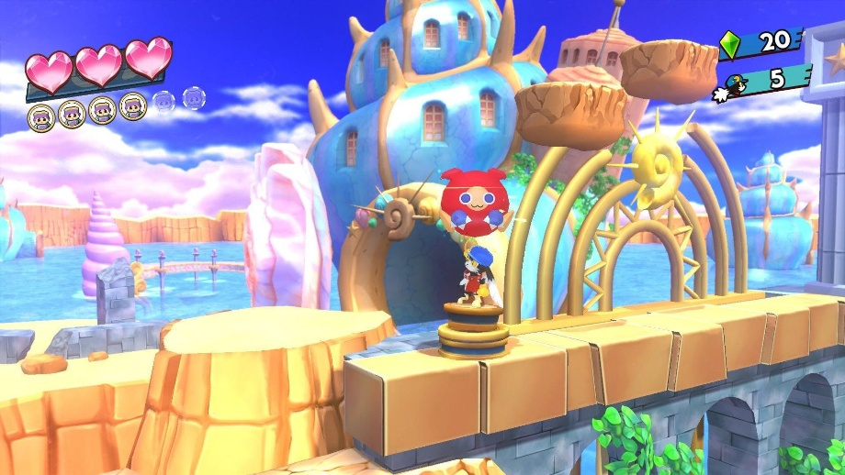
Gameplay:
Move set:
The character features upward movement in the form of a jump which can be extended by holding the jump button which make klonoa flap his ear and remain in the sky for longer periods.
The character can move to the left right of the level with the ability to interact with the world by using lifts which can take the player to the foreground or vertically upwards
The character can use the wind bullet to inflate enemies and grab them in the inflated state, where they can either use this for a double jump by pressing the jump button again or launch the enemy at switches or other enemies, this can be done in the foreground or the playable plane, being the player way to interact with the world in a 3d way.
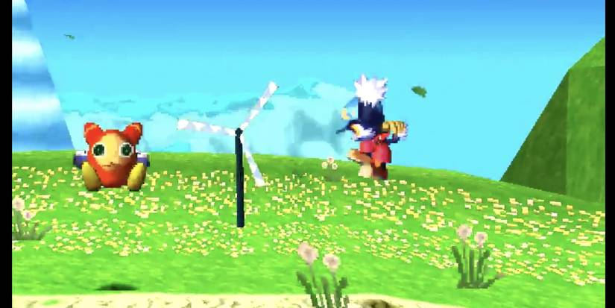
Whilst the move set is on the simpler side with only 2 different moves it uses these move’s and innovate on them throughout the game giving each a much larger amount of depth through their increased amount of uses. A great example of this is within vision 5:2, at a certain point the player use the lifts to get to a higher level but to carry on the player is required to use an enemy to jump higher to reach a platform, but no enemies are in that section so you take the exit to the right and proceed to use different types of jumps to hit a series of switches, releasing an enemy from a jail cell. Each switch requires you to use different mechanic with one requiring you use the springboard to launch yourself upwards then hit a switch, another requires the player to jump and use the float mechanic to float toward a switch before you re pulled back down to the ground, the 3rd requires the player to avoid enemies that can’t be killed, by observing their patterns then moving into the area with the switch before they can hit you, finally the final switch innovates on the first switch with springboard being used but now requiring the player to hit the switch whilst moving toward another springboard. Doing all this free the enemy allow you to inflate them and use in the original room to jump and get to the platform in the other room.
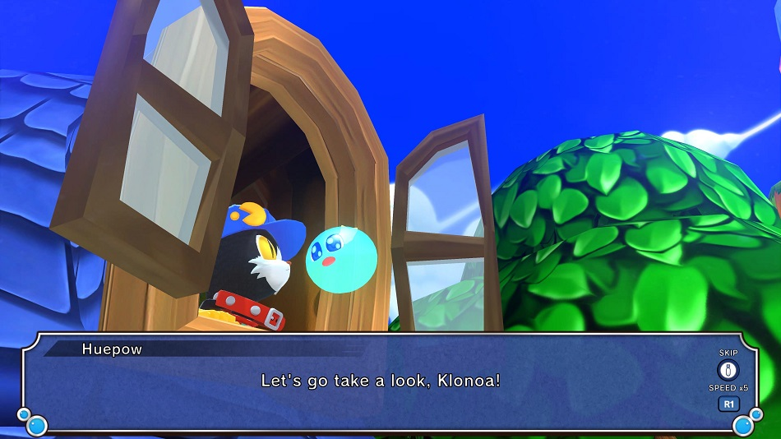
The game takes the simple move set and uses it in nearly every way imaginable, with other areas requiring you to chain your doubles jump to keep upwards momentum. This continual innovation on the 2-core mechanics along with the rising difficulty keep the player interested and continually present throughout the game, with gameplay never feeling boring or overly repetitive.
References:
(01) Dablais (2023) PC gamer issue 001 (May-June 1994), Retromags Community. Available at: https://www.retromags.com/files/file/6906-pc-gamer-issue-001-may-june-1994/ (Accessed: 23 September 2026).
(02) Interceptor - videogame by Taito (1976) Museum of the Game. Available at: https://www.arcade-museum.com/Videogame/interceptor (Accessed: 23 September 2026).
(03) Zaxxon - videogame by Sega/Gremlin (1982) Museum of the Game. Available at: https://www.arcade-museum.com/Videogame/zaxxon (Accessed: 23 September 2026).
(04) (No date) Interceptor images - giant bomb video game wiki. Available at: https://giantbomb.com/wiki/Objects/Interceptor/Images (Accessed: 23 September 2026).
(05) (No date a) Tomohiro Nishikado’s list of works. Available at: https://www.arcade-history.com/index.php?page=person&name=Tomohiro+Nishikado (Accessed: 23 September 2026).
(06) (No date a) • gjlm E MJLCIBNE game machine magaline i$ 臥Jbl Ist、 Ed Twi 田. Available at: https://onitama.tv/gamemachine/pdf/19830915p.pdf (Accessed: 23 September 2026).
(07) Video games player - vol 2 no 2 (1983-11)(carnegie publications)(us) : Free download, borrow, and streaming (1983) Internet Archive. Available at: https://archive.org/details/Video_Games_Player_Vol_2_No_2_1983-11_Carnegie_Publications_US/page/n55/mode/2up (Accessed: 23 September 2026).
(08) II computing vol 1 no 1 Oct Nov 85 premiere : Free download, borrow, and streaming (no date) Internet Archive. Available at: https://archive.org/details/II_Computing_Vol_1_No_1_Oct_Nov_85_Premiere/page/n51/mode/2up (Accessed: 23 September 2026).
(09) Petska-Juliussen (1990) The Computer Industry Almanac 1990 : Petska-Juliussen, Karen, 1948- : Free download, borrow, and streaming, Internet Archive. Available at: https://archive.org/details/computerindustry00kare/page/n267/mode/2up (Accessed: 23 September 2026).
(10) (No date a) Retrocdn. Available at: https://retrocdn.net/images/9/98/CompleteGuideToConsoles_UK_01.pdf (Accessed: 23 September 2026).
(11) (No date a) Retrocdn. Available at: https://retrocdn.net/images/9/98/CompleteGuideToConsoles_UK_01.pdf (Accessed: 23 September 2026).
(12) usa, arcade (2025) Zaxxon! (Arcade - Sega), YouTube. Available at: https://www.youtube.com/watch?v=6QPnHIP6pRg (Accessed: 23 September 2026).
(13) longplays, world of (2022) atari 2600 longplay [085} zaxxon us, YouTube. Available at: https://www.youtube.com/watch?v=RH5YWQkmpQA (Accessed: 23 September 2026).
(14) longplays, world of (2022b) https://www.youtube.com/watch?v=n2fiEkm5yY8, YouTube. Available at: https://www.youtube.com/watch?v=n2fiEkm5yY8 (Accessed: 23 September 2026).
(15) squaknet (2014) Zaxxon gameplay (PC Game, 1984), YouTube. Available at: https://www.youtube.com/watch?v=tpfU_Nh-y48 (Accessed: 23 September 2026).
(16) knapper, james (2026) unedited, longplay klonoa and the phantomile door, YouTube. Available at: https://www.youtube.com/watch?v=S9P_OITM2ek (Accessed: 26 September 2026).
(17) Staff, I. (2012) So very strange, IGN. Available at: https://www.ign.com/articles/1997/08/23/so-very-strange (Accessed: 26 September 2026).
(18) (No date) €"’. Available at: https://web.archive.org/web/20040611040009/http://www.namco-ch.net/event/tgs-97-au/report-9-7-02.html (Accessed: 26 September 2026).
(19) magazine, O. us playstation (2021) Official U. S. Play Station Magazine Volume 1 issue 06 ( March 1998) : Official US PlayStation Magazine : Free Download, borrow, and streaming, Internet Archive. Available at: https://archive.org/details/official-u.-s.-play-station-magazine-volume-1-issue-06-march-1998/page/n91/mode/1up (Accessed: 26 September 2026).
(20) Staff, I. (2012a) Klonoa: Gateway to phantomile, IGN. Available at: https://www.ign.com/articles/1998/03/12/klonoa-gateway-to-phantomile-2 (Accessed: 26 September 2026).
(21) Hyper 090 : Free download, borrow, and streaming (2001) Internet Archive. Available at: https://archive.org/details/hyper-090/page/48/mode/2up (Accessed: 26 September 2026).
(22) dulin, ron (1998) Klonoa Review - GameSpot, gamespot. Available at: https://www.gamespot.com/reviews/klonoa-review/1900-2545986/ (Accessed: 26 September 2026).
(23) Gamefan volume 6 issue 02 February 1998 : Free download, borrow, and streaming (1998) Internet Archive. Available at: https://archive.org/details/GamefanVolume6Issue02January1998/page/n55/mode/2up (Accessed: 26 September 2026).
(24) Edge (2021) Edge UK 086 : Edge : Free download, borrow, and streaming, Internet Archive. Available at: https://archive.org/details/edge-uk-086 (Accessed: 26 September 2026).
(25) Computer and video games - issue 198 (1998-05)(emap images)(gb) : Free download, borrow, and streaming (1998) Internet Archive. Available at: https://archive.org/details/Computer_and_Video_Games_Issue_198_1998-05_EMAP_Images_GB/page/n65/mode/2up (Accessed: 27 September 2026).
(26) Staff, I. (2012c) Square rules Japan, IGN. Available at: https://www.ign.com/articles/1998/04/07/square-rules-japan (Accessed: 27 September 2026).
(27) videogames.com present THE GAME OF THE YEAR (no date) Videogames.com’s the game of the year. Available at: https://web.archive.org/web/19990508143018/http://videogames.com/features/universal/awards98/sec5.html (Accessed: 27 September 2026).
(28) よしざわひでお on X: ‘クロノア１の開発が終わってしばらくした頃、本部長からお呼びがかかったのです。 その時、本部長からこんなことを言われたのです。 クロノアは２０万本程しか売れなかったけど、とってもいいゲームだと思う。’ / x: Ghostarchive (no date) Visit the main page. Available at: https://ghostarchive.org/archive/IxBvg (Accessed: 27 September 2026).
(29) Klonoa: Door to the Phantmile for PlayStation - summary, story, characters, maps (no date) VGChartz. Available at: https://www.vgchartz.com/game/3621/klonoa-door-to-phantomile/summary (Accessed: 27 September 2026).
(30) (No date a) Klonoa: Door to Phantomile | PlayStation wiki | fandom. Available at: https://playstation.fandom.com/wiki/Klonoa:_Door_to_Phantomile (Accessed: 26 September 2026).

